# ownCloud Server – Quick Start Guide

The instructions below describe the quickest way of installation and initial configuration of a fully functional ownCloud server. This method uses Docker—software that packages an application and its dependencies in a virtual container that can run on any operating system. To enable this method, ownCloud maintains [its Docker container available for installation](https://hub.docker.com/r/owncloud/server/tags).

## System Requirements

ownCloud needs at least 128 MB of RAM, but we recommend a minimum of 512 MB. The actual memory use of an ownCloud server depends on the number of users and files, and volume of server activity.

## Prerequisites

* Linux terminal   
  Although Docker containers can be run on any operating system, this set of instructions assumes that the machine has a Linux terminal. In particular, the Ubuntu 18.04 distribution is recommended.
* Docker Compose   
  Your machine should have the Docker software including Docker Compose installed. Refer to the Docker website for the installation instructions (<https://docs.docker.com/get-docker/>).

## Installation

**To install an ownCloud server, do the following:**

1. Open the Linux terminal. If needed, change the directory to the one in which you want to install ownCloud.
2. Create a new project directory:

mkdir {owncloud directory name}

1. Copy docker-compose.yml from the GitHub repository and paste it into the new directory.

cd {owncloud directory name}

# Copy docker-compose.yml from the GitHub repository

wget https://raw.githubusercontent.com/owncloud/docs/master/modules/admin_manual/examples/installation/docker/docker-compose.yml

1. Create a .env configuration file that contains the required configuration settings (in curly brackets below):

cat << EOF > .env

OWNCLOUD_VERSION={version number, e.g.,10.6, or latest}

OWNCLOUD_DOMAIN={Static IP address or domain name}:8080

ADMIN_USERNAME={username}

ADMIN_PASSWORD={password}

HTTP_PORT=8080

EOF

**Note**: ADMIN_USERNAME and ADMIN_PASSWORD will not change between deploys even if you change the values in the .env file. To change them, you will have to run docker volume prune, which **will delete all your data**.

1. Build and run the container *{one container?}* using [Docker Compose](https://docs.docker.com/compose/):

docker-compose up -d

1. When the process completes, check that all the containers *{several containers?}* have successfully started by running docker-compose ps.

The output shows that all containers are Up and ownCloud is accessible via port 8080 on the host machine.

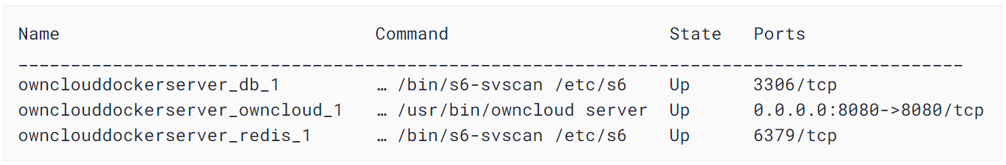

**Note**: Although the containers are up and running, it may still take a few minutes until ownCloud is fully functional. To know exactly when you may start using the server, run docker-compose logs --follow owncloud and inspect the log output. When the output shows "Starting apache daemon…", you may access the web UI.

## Logging In

**To log in to the ownCloud UI:**

1. Open [http://localhost:8080](http://localhost:8080/) in your browser of choice.

The ownCloud login screen opens.

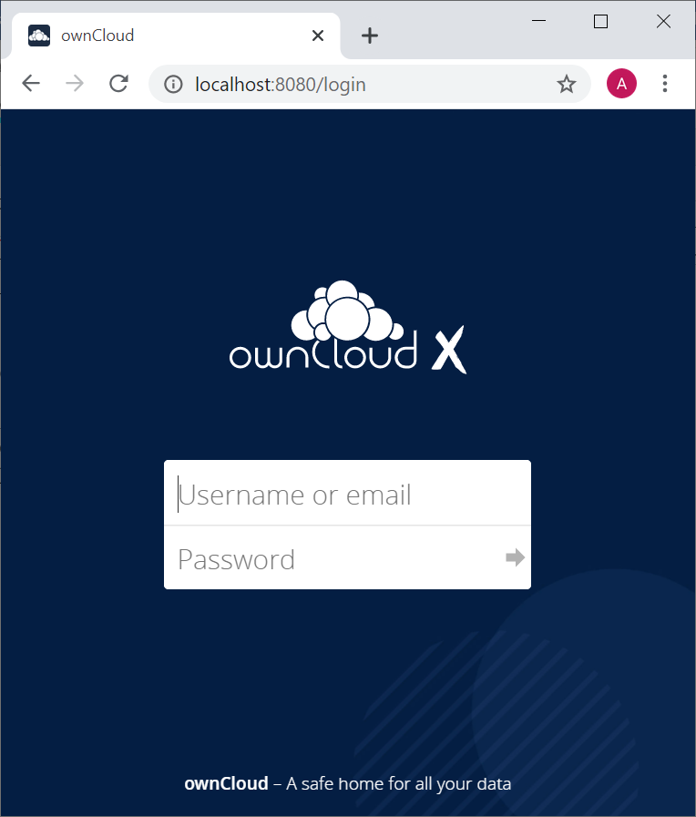

1. Enter the admin username and password that are stored in the .env file. Click the arrow.

The ownCloud UI opens.

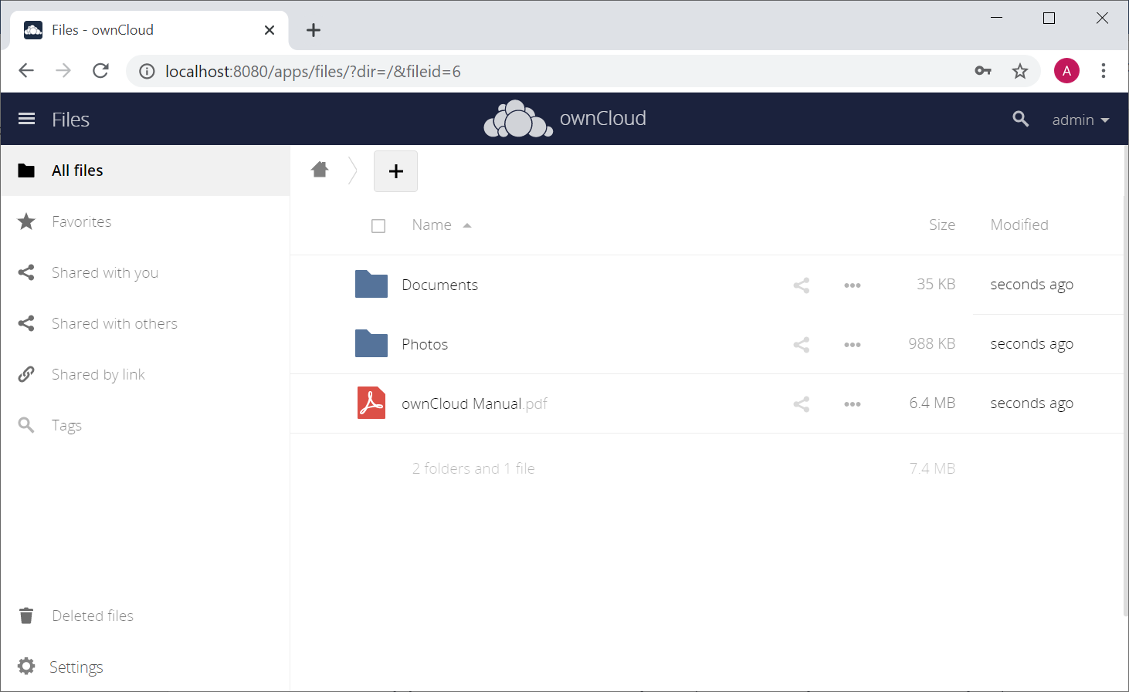

## Adding a User

**To create a new user of the ownCloud server, do the following:**

1. Open the Admin drop-down menu in the upper left corner of the screen and select Users.

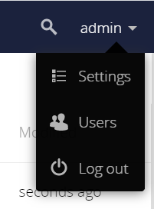

The Users screen opens.

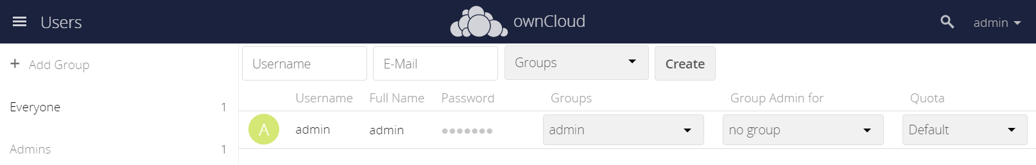

1. Enter the new user’s username and email address.

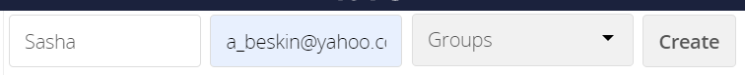

Usernames may contain lowercase and uppercase letters, numbers, dashes, underscores, periods and @ signs.

Optionally, to assign the new user to a group, select the group from the Groups drop-down menu.

1. Click the **Create** button.

The new user is added to the list of existing users.  
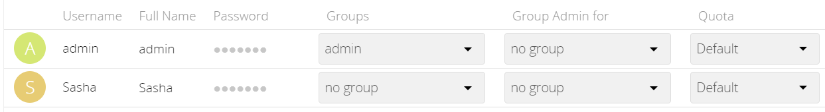  
You may fill in the user’s full name if it is different from the username

1. Set a password for the new user:
2. Hover the cursor over the new user’s Password field.
3. Click on the pencil icon.
4. Type in the user’s new password and press Enter.   
   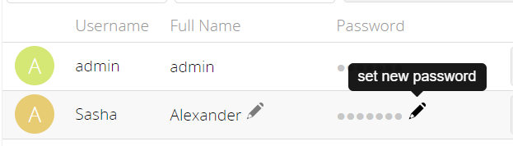
5. To enable the new user to use the ownCloud server, provide them with the following information:

* Address for accessing the ownCloud UI: <domain name>:8080 or <IP address>:8080
* Username
* Password

Instruct the user that the UI of the ownCloud server can be accessed by opening the provided address in any browser and entering the login credentials.

## Stopping the Containers *{do I need it here?}*

To stop the containers, use docker-compose stop

To stop and remove containers completely (including the related networks, images, and volumes), use docker-compose down --rmi all --volumes